GIt & Github Tutorial:

# GIT:

## What is Git?

* It is a Free and open-source version control system
* It is a tool that tracks the changes in your code overtime.

## What is version control:

* The management of changes to documents, computer programs, large web sites and other collections of information.
* Some terms regularly used:
  + Directory -> Folder
  + Terminal or Command line -> Interface for Text Commands
  + CLI -> Command Line Interface
  + Cd -> change directory
  + Code Editor -> Word processor for writing code, e.g., VS-code
  + Repository -> Project, or the folder/place where your project is kept.
  + GitHub -> a website to host your repositories online.

## Some Basic Git commands:

* All the commands are in the lowercase unless explicitly written in capital
  + Clone -> Bring a repository that is hosted somewhere like GitHub into a folder on your local machine.
  + Add -> Track your files and changes in Git.
  + Commit -> Saves your files in Git.
  + Push -> Upload Git commits to a remote repo, like GitHub.
  + Pull -> Download changes from remote repo to your local machine, the opposite of push.
  + Branch -> Shows in which branch you’re working.
  + Checkout -> To switch/create new branches.

## How to create a new repository from GitHub:

* All the commands are in the lowercase unless explicitly written in capital
* Step 1:
  + Hover over the (+) drop down and click on new repository
* Step 2:
  + Enter your repository name and description.
* Step 3:
  + A new repository is created.
  + Always create a README.md file in the repository manually.

## How to import, update and push the repository:

* Step 1: All the commands are in the lowercase unless explicitly written in capital
  + Always check git version using the git bash or cmd.
  + **Git –version**
* Step 2:
  + **Git clone (Enter the link of the repository provided on the GitHub)/(SSH link generated)**
* Step 3:
  + Make the changes on the local machine and check the status of the file using the following command.
  + **Git status**
* Step 4:
  + Then if you create a new file in the repository locally; the file is then added to repository locally.
  + This tracks the file in the repository.
  + **Git add .(period) or Git add filename.extension**
* Step 5:
  + We commit the changes made with the command.
  + **Git commit -m “Changes to the Title of the file” -m “Description of the Heading” -m stands for message.**
* Step 6:
  + We push the changes on the internet using the command.
  + **Git push origin (branch)**

## Perquisite to push your local repository:

* All the commands are in the lowercase unless explicitly written in capital
* To push your repository under “XYZ” account it needs authentication/proving to GitHub.
* Therefore, connect your local machine to your GitHub account using SSH Keys.
* Step 1:
  + Type the following command:
  + **Ssh-keygen -t rsa -b 4096 -C “**[**email@example.com**](mailto:email@example.com)**”**
  + Enter the passphrase as needed or keep it empty.
  + Note the location of the key stored at.
* Step 2:
  + Navigate to the folder/directory where the SSH key is stored.
  + Using “**ls | grep testkey**” on Linux/macOS search for testkey.pub
* Step 3:
  + Copy the testkey.pub
  + Testkey.pub is the key that is going to be uploaded on GitHub’s interface
* Step 4:
  + Navigate to SSH/GPG on GitHub
  + Paste the copied public key by adding a new ssh key on the browser.
  + And confirm the access.

## How to create a repository locally and push:

* All the commands are in the lowercase unless explicitly written in capital
* Step 1:
  + Create a new folder and type “**git init**”, this initializes an empty git repository.
* Step 2:
  + Fill the details in the local folder/directory and commit the changes locally.
  + To perform this step, refer step 4 and step 5 of how to import, update, and push.
* Step 3:
  + Create a new repository on the GitHub and copy the link.
  + Use “**git remote add origin (copied link)**”
  + This connects the empty repository on the GitHub to the local machine.
* Step 4:
  + Use “**git remote -v**” to check if the connection is made or not.
  + Use “**git push location(origin) branch(master)**” to push the repository on the GitHub.
  + Use “**git push -u location(origin) branch(master)**” to setup an upstream for that branch.

## Workflow of the GitHub and Local machine:

* The workflow is shown as follows:
* 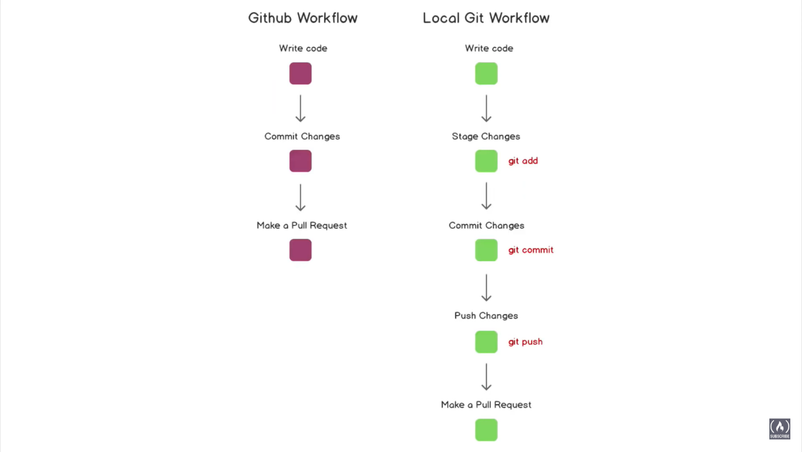

## How to create and delete a branch:

* All the commands are in the lowercase unless explicitly written in capital
* Step 1:
  + Use “**git branch**” to see which branches are created.
* Step 2:
  + To create a new branch.
  + “**git checkout -b (branch_name)**”
* Step 3:
  + To delete a branch.
  + “**git branch -d (branch Name)**”
  + “**git branch -D (branch Name)**”
* Note:
  + All changes made to an individual branch will not be reflected in another branch unless merged.
  + To switch into different branches:
  + “**git checkout branch_name**”

## How to create a pull request:

* All the commands are in the lowercase unless explicitly written in capital
* Step 1:
  + Create a new branch
  + Perform all the changes in that branch.
* Step 2:
  + Commit and push the changes on the GitHub.
* Step 3:
  + Check the difference between the main branch and the feature branch.
  + If there are any differences, switch to main branch.
  + “**git diff (branch_name)**”
* Step 4:
  + Merge the main branch with the feature branch.
  + “**git merge (branch_name)**”

## How to update your local repository:

* All the commands are in the lowercase unless explicitly written in capital
* Step 1:
  + “**git pull origin master(branch_name)**” to update changes on local machine that are made on GitHub.
  + “**git pull**” if the upstream settings have been mentioned already for that branch.

## How to upload large files that are over 100mb:

* All the commands are in the lowercase unless explicitly written in capital
* Step 1:
  + “**git lfs install**” install the git large file storage to upload.
* Step 2:
  + **git lfs track "*.ext"**
  + To track the large files that you wish to upload on GitHub.
* Step 3:
  + To upload the files on the repository, follow the commands below:
    - **git add file.ext**
    - **git commit -m "Add design file"**
    - **git push origin main**